**MIS 545 Data Mining Description**

**Predicting a Song’s Genre**

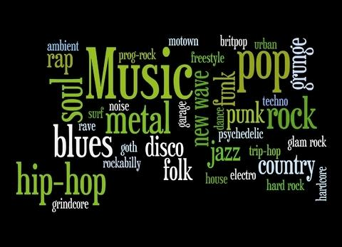

**by**

**Kirsten Fure**

**August 2019**

**Problem Description**

With the popularity of digital music, there has been great interest in browsing, searching and organizing large music collections. Users become overwhelmed with the volume of music and desire recommendations for music they might like. In order to provide these predictions to users, first one must categorize music into types/genres and then into sub-genres. Many songs span several genres and consist of a combination of sub-genres. In order to categorize music in such a detailed way, it would be useful to have a computer program which could predict a song’s genre. The goal of this project is determine if we can predict a song’s top-level genre based upon a set of attributes and musical features contained in the database. Questions I will explore include:

* What elements of a song are similar among genres?
* Is it possible to predict a song’s genre given the data within this database?
* How accurate can we be in our predictions?

**Executive Summary of Results and Findings**

Categorizing songs into genres is a difficult task. Often two people listening to a song can’t agree on a song’s genre, and there is a lot of crossover in music. Some pop songs will have elements of Jazz or Folk, vice versa. Using a computer program to predict a song’s genre is no less complex. It requires a decent number of musical attributes and records, but does result in a prediction better than baseline. The decision tree proved to perform better than Naive Bayes in this project.

**Project Dataset Description**

For this project, I used the FMA (Free Music Archive) Database. It includes audio information for 106,574 tracks from 16,341 artists and 14,854 albums. It consists of 9 relational databases, and has a hierarchical structure of assigned genres that expands to 161 sub-genres. There are 17 different top-level genres. The database contains the full-length audio and related information to the track, artist and the album. The dataset also includes detailed features about the music that have been extracted using a program called libROSA. This python-based program has been run on each audio track and the database includes numerous musical features such as: spectral, rhythm, manipulation, inversion, bandwidth, flatness, roll-off frequency, tonnetz (tonal centroid), and many other special features such as chromagrams. These features are represented as continuous attributes.

The data consists of the following csv files:

1. Tracks.csv
2. Features.csv
3. Echonest.csv
4. Genres.csv
5. Raw_albums.csv
6. Raw_artists.csv
7. Raw_echonest.csv
8. Raw_genres.csv
9. Raw_tracks.csv

The Tracks table contains 106,574 rows and 53 columns and contains information about the song, artist, title, bitrate, etc..

The Features table contains 106,574 rows 519 columns, which mostly consists of continuous values of musical features relating to: Chroma Energy Normalized” (CENS), Constant-Q chromagram, chromagram from a waveform, Mel-frequency cepstral coefficients (MFCCs), root-mean-square (RMS), spectral centroid, spectral bandwidth, spectral contrast, Spectral flatness (or tonality coefficient), roll-off frequency, tonal centroid features (tonnetz), etc.

The Echonest table contains interesting data, but only for a subset of the songs. I did extensive analysis including this data, but found that the attributes from the Features table were actually giving better accuracy ratings. Due to the fact that the Echonest table did not include all the songs and was not increasing accuracy, I decided not to use this table in my final analysis.

**Data Preprocessing / Transformation**

In order to make the data more manageable, I selected 3 genres to work with. I created a subset of the original data by selecting Folk, Classical and Hip-Hop music and the columns that were relevant to this project. I only selected songs that had a top-level genre and no missing data. There were 1230 Classical songs, 2803 Folk songs and 3552 Hip-Hop songs in my subset.

In the features data, I also created a subset of columns from 519 variables to 12. I merged these 2 tables based upon Track_ID. I chose the following continuous independent variables:

* Track bitrate
* Chroma Energy Normalized (chroma-CENS)
* Constant-Q chromagram (chroma-cqt),
* Chromagram from a waveform (chroma-stft)
* Mel-frequency cepstral coefficients (MFCCs),
* Root-mean-square (RMSE),
* Spectral centroid,
* Spectral bandwidth,
* Spectral contrast,
* zero-crossing rate (zcr),
* roll-off frequency,
* tonal centroid features (tonnetz)

|  |  |  |  |  |
| --- | --- | --- | --- | --- |
| **Table** | **Field Name** | **Variable Type** | **Data Format** | **Description** |
| Tracks.csv | Track_ID | IV | int | Unique identifier for each song. Used to merge tables. |
| Tracks.csv | Track_bitrate | IV | int | Number of bits per unit of time |
| Tracks.csv | Track_genre_top | DV | factor | Music genre category |
| Features.csv | Chroma_cens | IV | num | Chroma Energy Normalized |
| Features.csv | Chroma_cqt | IV | num | Constant-Q chromagram |
| Features.csv | Chroma_stft | IV | num | Chromagram from a waveform or power spectrogram |
| Features.csv | Mfcc | IV | num | Mel-frequency cepstral coefficients |
| Features.csv | Rmse | IV | num | Root-mean-square |
| Features.csv | Spectral_bandwidth | IV | num | Spectral bandwidth |
| Features.csv | Spectral_contrast | IV | num | Spectral contrast |
| Features.csv | Spectral_centroid | IV | num | Spectral centroid |
| Features.csv | Spectral_rolloff | IV | num | Spectral rolloff for each frame |
| Features.csv | Tonnetz | IV | num | tonal centroid features |
| Features.csv | zcr | IV | num | zero-crossing rate |

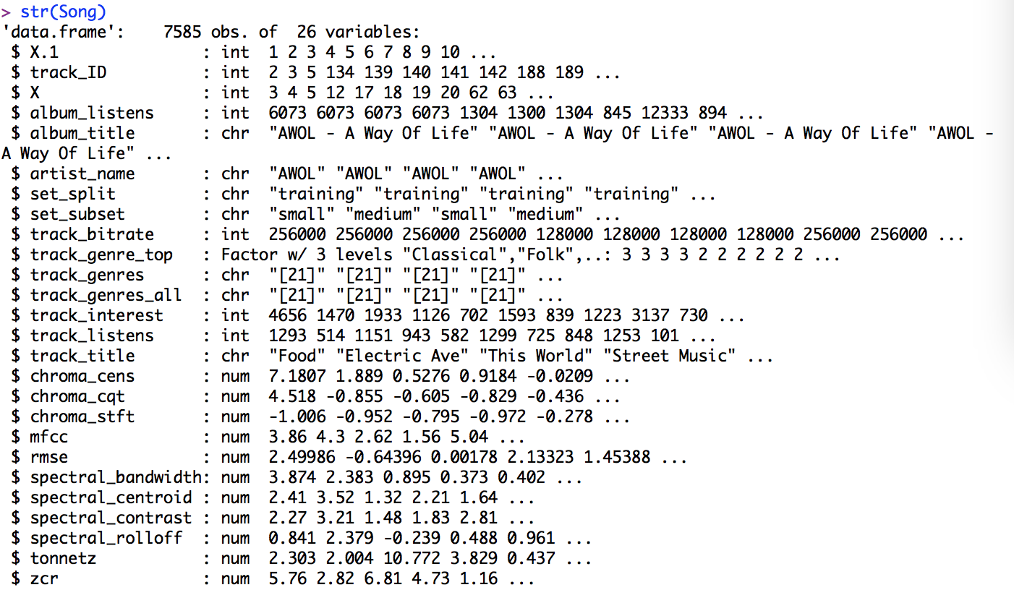Here is the structure and summary of the subset data:

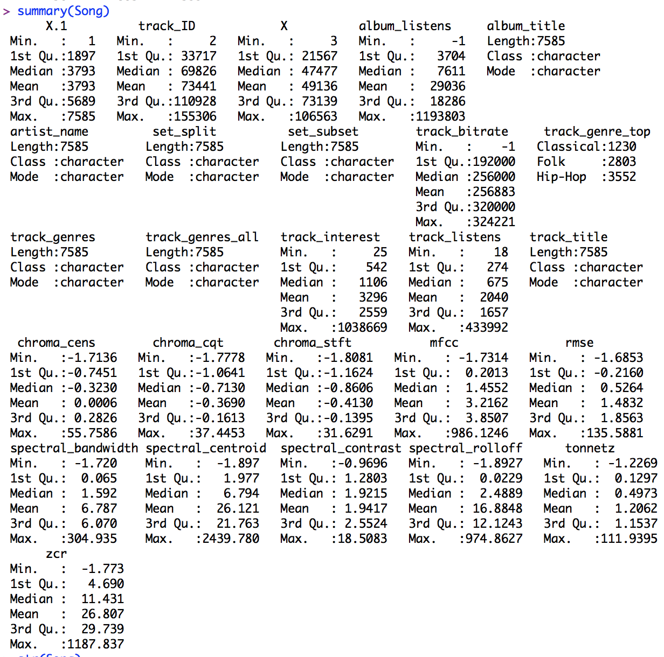

**Feature Selection - Descriptive Analysis**

I used linear regression for feature selection, converting my dependent variable to numeric. I used StepAIC both ways (forward and backward) in order to get the best results. The final model recommended 10 of the 12 independent variables, making it difficult to eliminate many attributes.

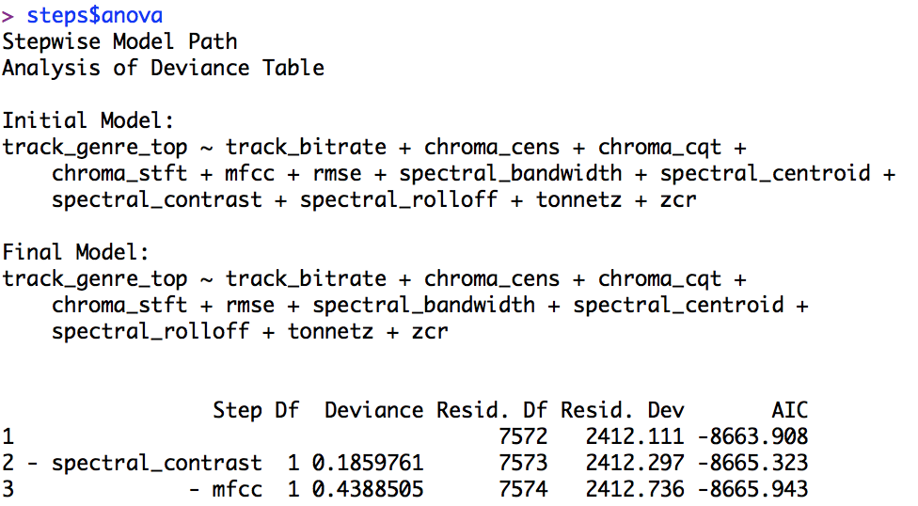

I also used the conditional random forest algorithm and the varimp() function to determine variable importance according to this method. I ran it with 50 trees max and with 500 and the results gave similar orders of variable importance.

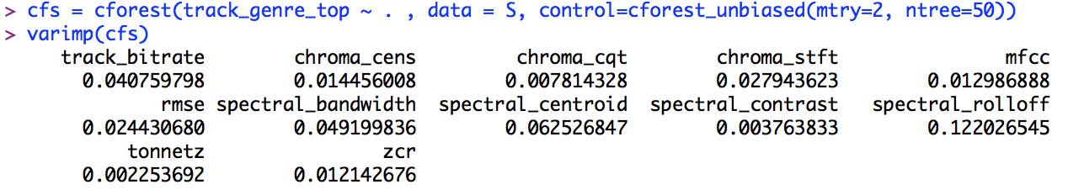

When I change ntry to a higher value (like 12), I get slightly different results in variable importance. Spectral bandwidth is more important and centroid less.

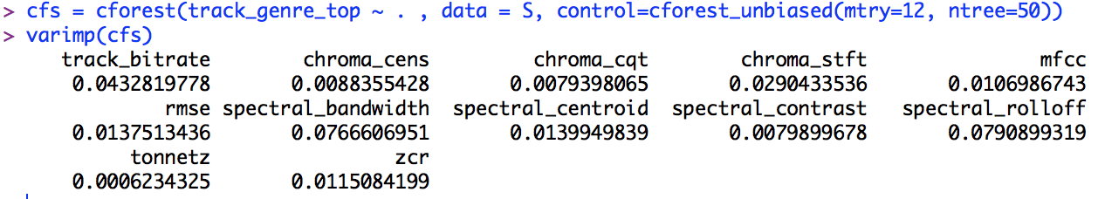

Linear Regression and Random Forest give slightly different results. The random forest indicates that tonnetz is the least important, followed by chroma_cqt, spectral_contrast, , chroma_cens, mfcc, and zcr. They both seem to agree that spectral_contrast is lower in importance and possibly mfcc too.

**Associated Rule Analysis**

In order to use associated rule analysis and the apriori function, I needed to convert the continuous independent variables into categorical. I used the discretize function to do this.

The overall top 7 rules (sorted by support, confidence or lift) all indicated Hip Hop as the genre. Spectral_rolloff, Spectral_centroid, Spectral_Bandwidth are important indicators for Hip Hop. Also chroma_stft and rmse make an impact.

For the Folk genre, the top variables were chroma_cqt, chroma_stft, spectral_rolloff, and zcr. Spectral_bandwidth and spectral_centroid also make an impact.

For the Classical genre, spectral_bandwidth, spectral_centroid, spectral_rolloff and zcr are the biggest indicators.

According to the association rules, chroma_cens and tonnetz do not make a big impact to any genre indication. Also, chroma_stft and rmse are less important.

**Macintosh HD:Users:kirsten 1:Documents:Masters Programs:MIS 545 Data Mining - UofA:Project:Graph for Top7Rules.pdf**

Top 7 overall rules:

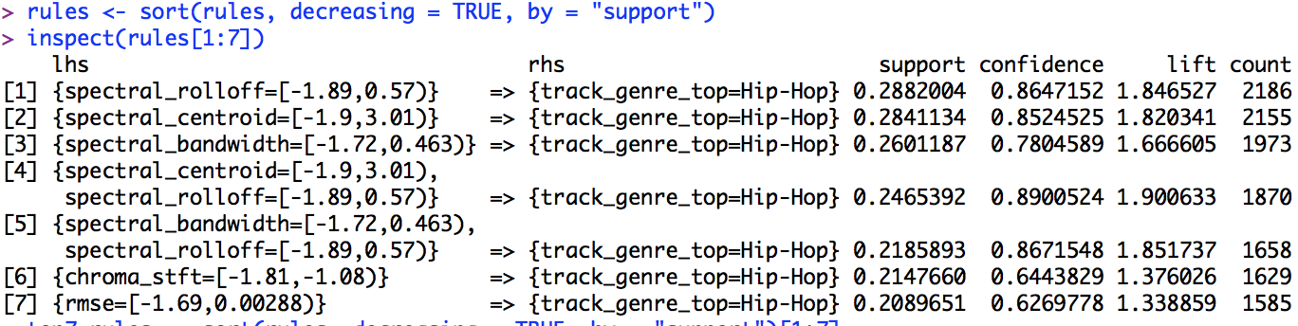

**Macintosh HD:Users:kirsten 1:Documents:Masters Programs:MIS 545 Data Mining - UofA:Project:Top5 rules graph for Folk.pdfTop 5 rules for Folk music genre:**

**Top 5 rules for Classical music:**

Macintosh HD:Users:kirsten 1:Documents:Masters Programs:MIS 545 Data Mining - UofA:Project:Top5 Rules Class.pdf

**Feature Selection Exploratory Analysis**

To analyze the data, I looked at relationships between genre and the individual attributes. No single attribute showed a strong exclusive relationship.

Here are some graphs showing how these values associate with the genres:

Macintosh HD:Users:kirsten 1:Documents:Masters Programs:MIS 545 Data Mining - UofA:Project:VioPlot Rolloff.pdf

Macintosh HD:Users:kirsten 1:Documents:Masters Programs:MIS 545 Data Mining - UofA:Project:Boxplots:BoxPlot Spectral Rolloff color.pdf

Macintosh HD:Users:kirsten 1:Documents:Masters Programs:MIS 545 Data Mining - UofA:Project:VioPlot Centroid.pdf

Macintosh HD:Users:kirsten 1:Documents:Masters Programs:MIS 545 Data Mining - UofA:Project:Boxplots:BoxPlot Spec Centroid.pdf

**Macintosh HD:Users:kirsten 1:Documents:Masters Programs:MIS 545 Data Mining - UofA:Project:Elbow Curve for Norm Data.pdfDescriptive Analysis with Clustering Analysis**

I ran K-means clustering on all the continuous independent variables (normalized) to see if there are interesting relationships. Because my subset data has 3 genres and the elbow curve supports that value, I chose K=3 for the number of clusters.

I used the fviz_cluster() function to visualize the clusters for all variables and was able to change the x and y coordinates to different variables in my dataset. Most of the clusters were nested, showing that K-means is not the best algorithm for this dataset. Hierarchical clustering may give

better results.

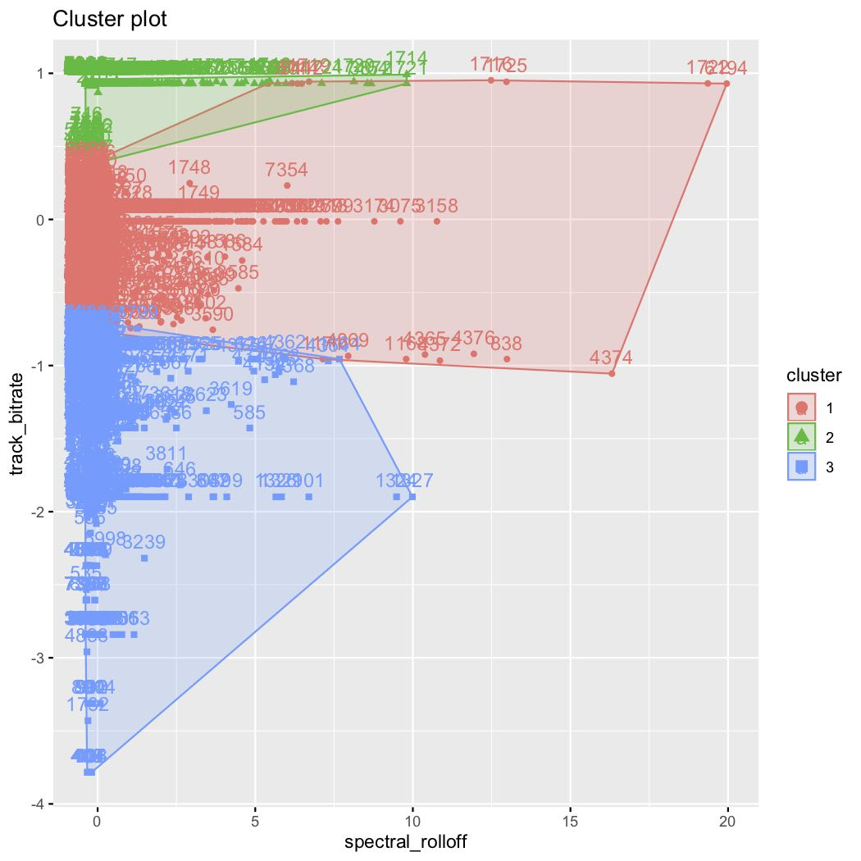Spectral Rolloff and Bitrate had the best separated clusters.

Here are just a few of some examples of other clustering combinations, showing nesting:

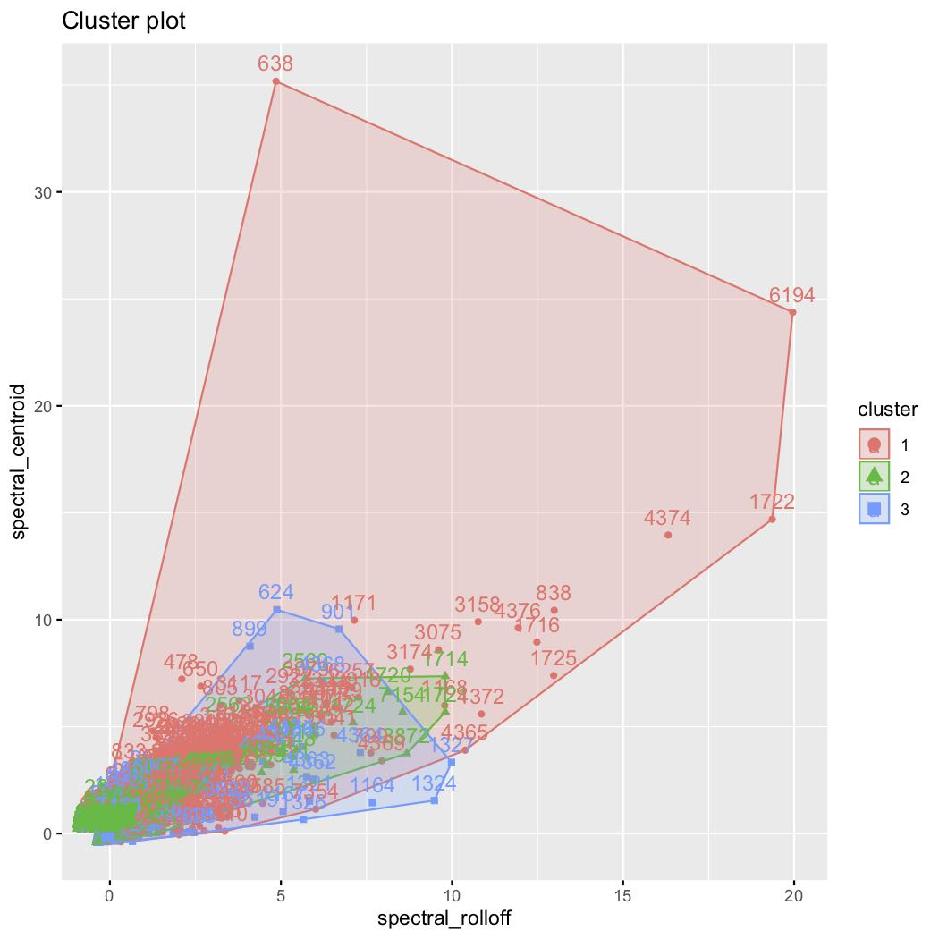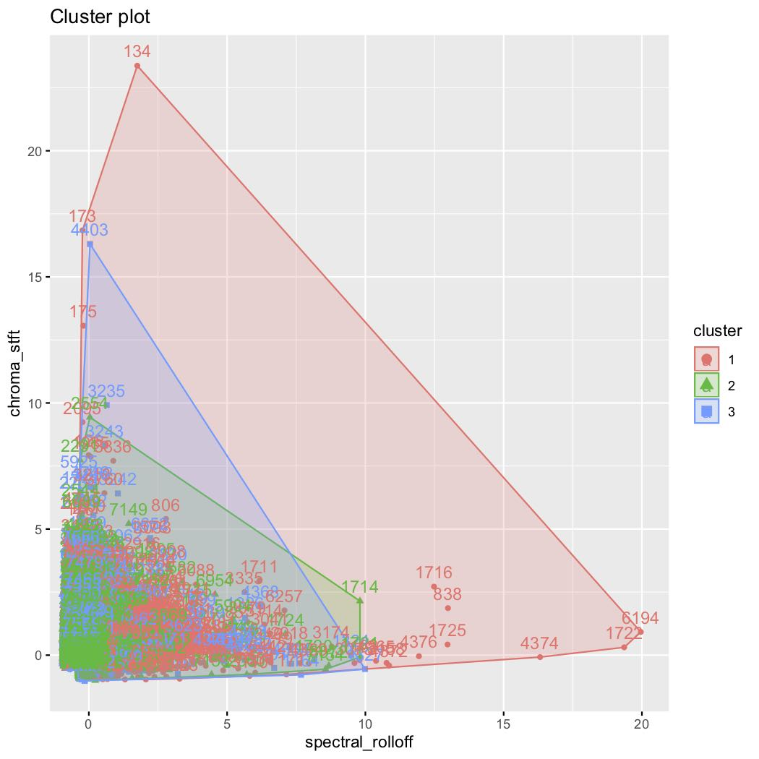

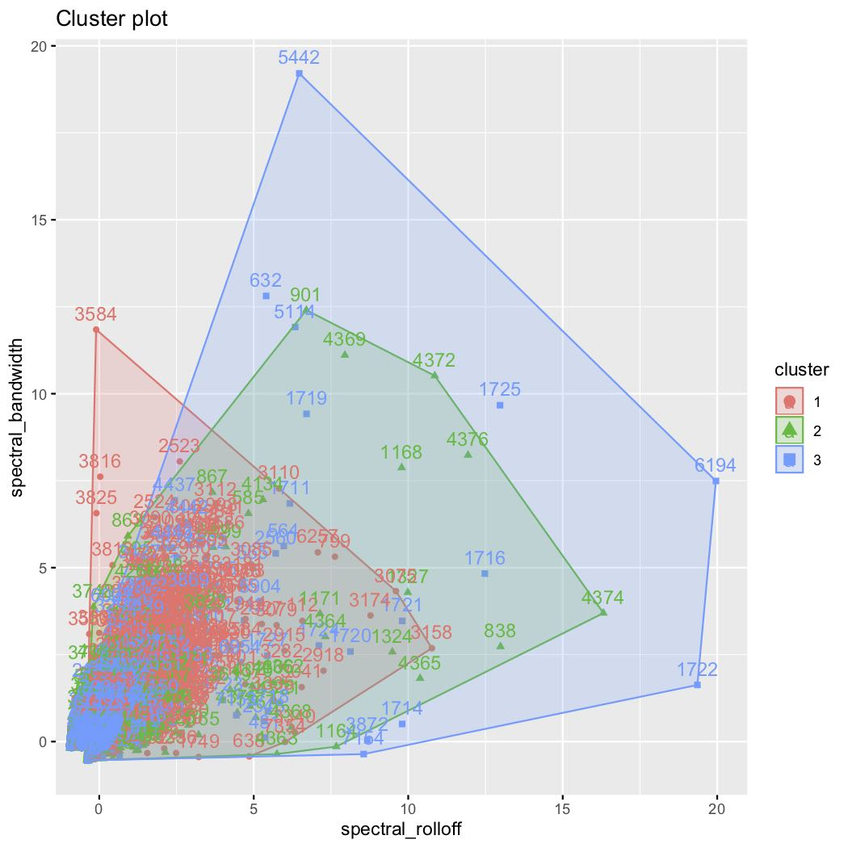

**Descriptive Analysis with Hierarchical Clustering**

I ran hclust() to see if hierarchical clustering could give more insight.

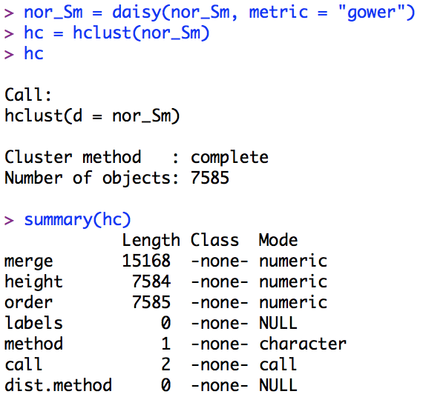

The resulting dendogram is complex and shows the nesting nature of the attributes.

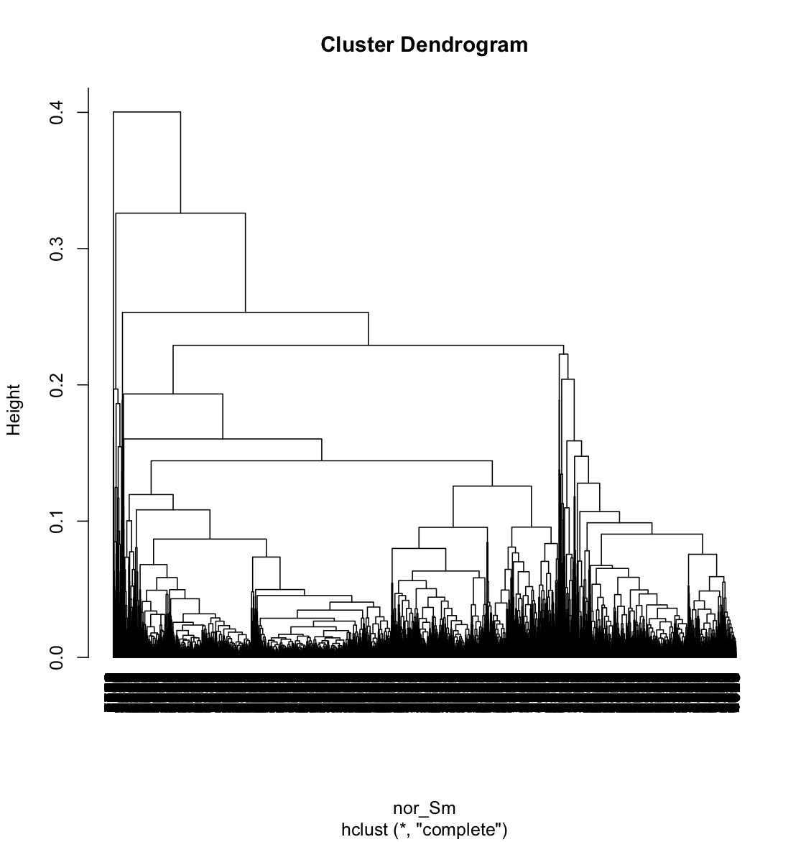

**Predictive Analysis with Decision Tree**

I created training data with an 80% random subset of data using all independent variables, and created testing data as the other 20% of records. I ran the decision tree on the training data and it created 57 sub-trees total.

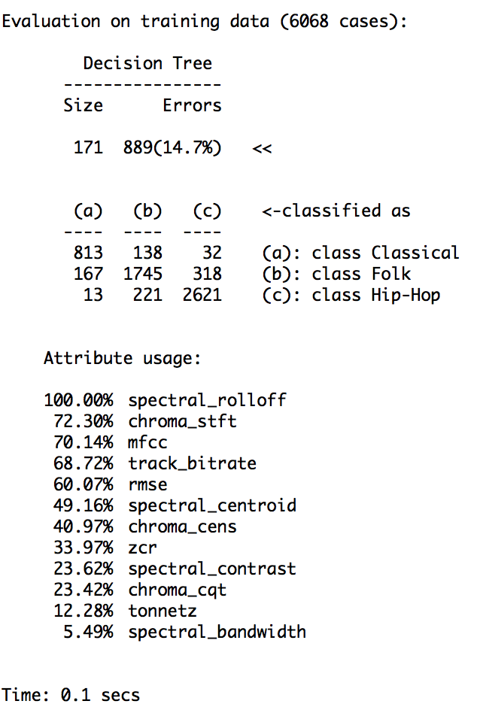



This high-level chart of the decision tree shows how the algorithm split the data at the top sub-trees, and shows that spectral rolloff, chroma stft, and track bitrate had the biggest impact.



The entire decision tree consists of 57 sub-trees and is complex to visualize.

**Evaluation of the Decision Tree Model**

I ran the prediction with the testing dataset, and compared whether the predicted genre matched the actual genre.

The decision tree accuracy was **74%** and here is the resulting confusion matrix showing the testing data.

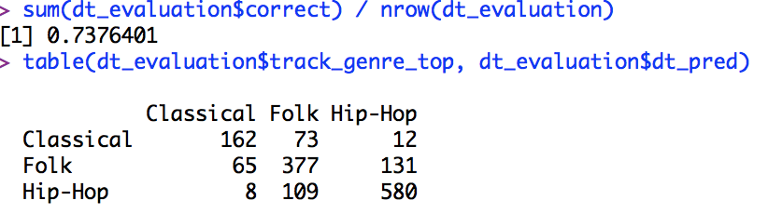

The Recall/True Positive Rate (True Positive for Class / Actual for Class):

Classical 66% (162/247 = 66%)

Folk 66% (377/573 = 66%)

Hip-Hop 83% (580/697 = 83%)

Average Recall – 71.5%

The Precision (True Positive for Class / Predicted for Class):

Classical 69% (162/235 = 69%)

Folk 67% (377/559 = 67%)

Hip-Hop 80% (580/723 = 80%)

Average Precision – 72%

These evaluation metrics for precision and recall show that the decision tree model is doing a fairly good job of predicting the genre. The Recall and Precision are balanced, so it has similar performance in predicting correctly and false predictions.

There are different ways to calculate the F1 score: macro, weighted and micro. Since we did not discuss the differences for multi-class situations in our class, I will use the simplest macro average calculation. F1 can be misleading for multi-class situations and favor the lower numbers.

F1 Score [2 × (precision × recall)/(precision + recall)]:

Classical 67%

Folk 67%

Hip-Hop 82%

Overall Macro Average F1 Score – 72%

**Predictive Analysis with Naïve Bayes**

I ran the Naïve Bayes algorithm on the training data with all independent variables and then ran prediction with the testing dataset.

Macintosh HD:Users:kirsten 1:Documents:Masters Programs:MIS 545 Data Mining - UofA:Project:NB bar chart .pdf

This chart of the Naïve Bayes model shows that it was very successful in predicting Hip-Hop (hence the large light grey area), and fairly good at predicting Classical (hence the larger dark grey area. But, it struggled to predict Folk correctly; we would want the medium grey area to be the largest, but unfortunately it was incorrectly predicting Hip-Hop more often.

**Evaluation Analysis of the Naïve Bayes Model**

Comparing predicted genre with the actual genre gave an accuracy rating of **62%,** so the decision tree had better results.

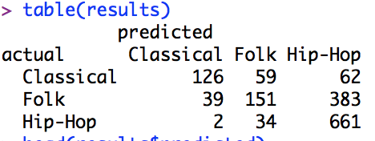

The Recall/True Positive Rate (True Positive for Class / Actual for Class):

Classical 51%

Folk 26%

Hip-Hop 94%

Average Recall – 57%

The Precision (True Positive for Class / Predicted for Class):

Classical 75%

Folk 62%

Hip-Hop 60%

Average Precision – 66%

These evaluation metrics for precision and recall show that the Naïve Bayes algorithm is usually doing better at predicting than pure guessing, but had a large number of wrong predictions for Folk. It predicted Hip-Hop many times when it was a Folk song. It did a very good job at recognizing Hip-Hop songs when they were actually Hip-Hop; it just seemed to think many Folk songs were also Hip-Hop.

There are different ways to calculate the F1 score: macro, weighted and micro. Since we did not discuss the differences for multi-class situations in our class, I will use the simplest macro average calculation. F1 can be misleading for multi-class situations and favor the lower numbers.

F1 Score [2 × (precision × recall)/(precision + recall)]:

Classical 60%

Folk 37%

Hip-Hop 73%

Overall Macro Average F1 Score – 57%

Using R to calculate statistics of the Naïve Bayes Model:

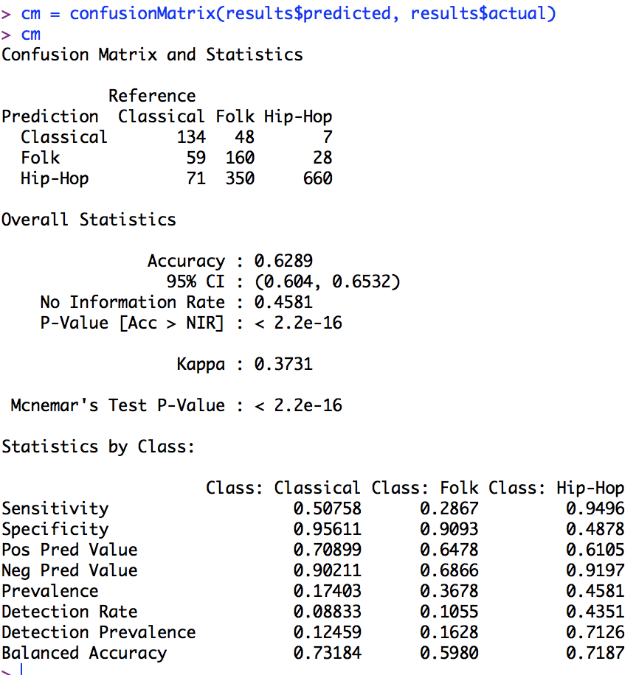

**Fine-Tuning Attributes**

After combining all the analysis, I chose 5 top attributes (spectral_rolloff, track_bitrate, chromas_stft, spectral_bandwidth and spectral_centroid) and re-ran the Decision Tree receiving the same 74% accuracy and very similar RTree of the top attributes.

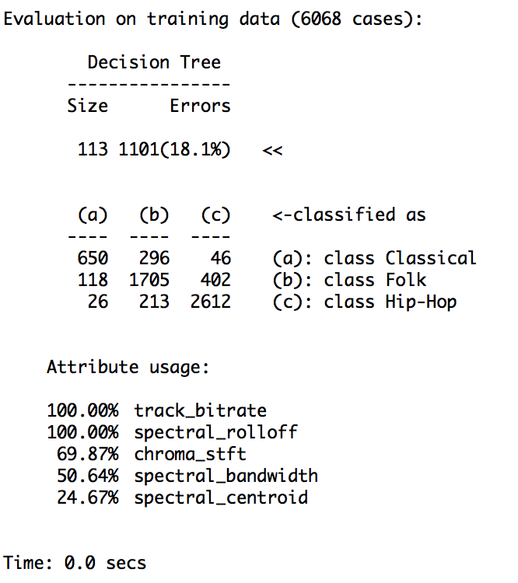

Macintosh HD:Users:kirsten 1:Documents:Masters Programs:MIS 545 Data Mining - UofA:Project:RTree smaller subset.pdf

Statistics of Decision Tree with top 5 attributes:

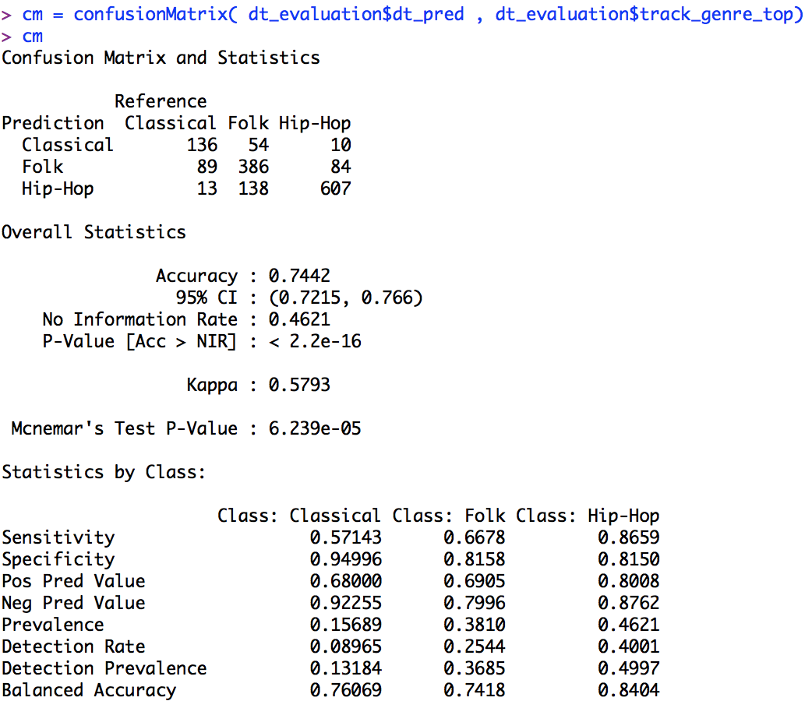

I also re-ran the Naïve Bayes model with the same top 5 attributes chosen and received similar accuracy at 62% and similar statistics.

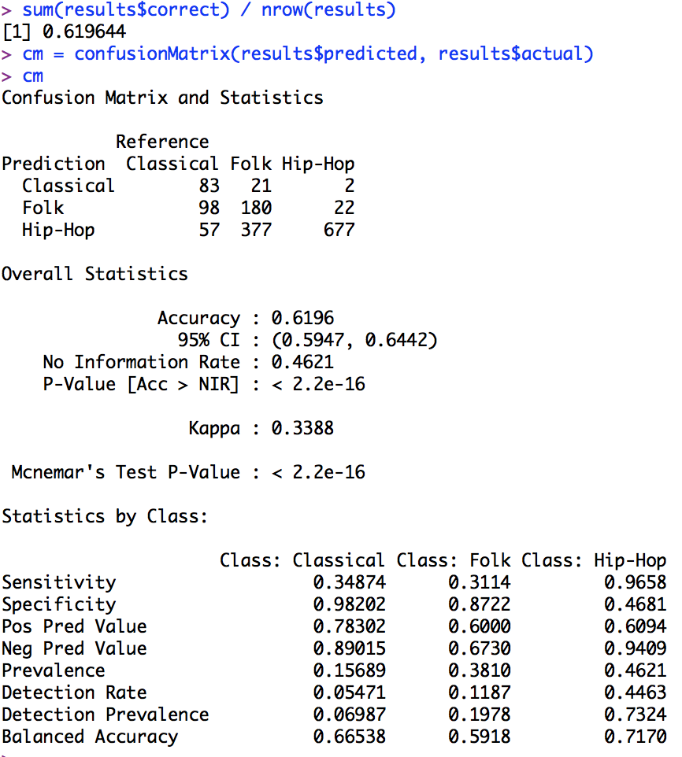Statistics for Naïve Bayes with top 5 attributes:

**Summary Conclusions**

It is possible to predict music genre based upon attributes, but we don’t get 100% accuracy. The Decision Tree performed the best at 74% accuracy, and the Naïve Bayes method had 62% accuracy

Each method used indicated different attributes as most important, however after combining all the results and choosing 5 top attributes, I was able to match similar performance in the two models as with 12 attributes.

In the future, I would recommend applying more hierarchical clustering methods to obtain more insight into the data, because it seems the attributes and relationships are nested. I would also like to compare the results from the Decision Tree and Naïve Bayes with Neural Network and SVM algorithms. Then I recommend taking the best performing model and run it on the full dataset with all the genres.